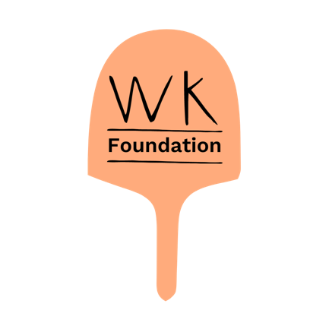

**WK Foundation & Well Kneaded Ltd Modern Slavery Policy**

**Introduction**  
WK Foundation, in partnership with Well Kneaded, is committed to preventing modern slavery and human trafficking across our operations and supply chains. We recognise our responsibility to act ethically and with integrity in all our business dealings.

**Our Commitment**

* We oppose modern slavery, forced labour, human trafficking, and exploitation.
* We expect our suppliers, contractors, and business partners to uphold these values and comply with all relevant laws.

**Our Practices**

* **Training & Awareness**: We make sure that our teams are kept up to date, with training and information to help them understand the risks of modern slavery and identify potential signs of exploitation. Training includes:
  + Recognising indicators of forced labour, human trafficking, and exploitation.
  + Guidance on reporting concerns internally and to relevant authorities.
  + Understanding the Modern Slavery Act 2015 and its application to our work.
  + Awareness of modern slavery risks in supply chains and mitigation steps.
  + Ongoing education and refresher courses to maintain awareness.
* **Supply Chain Due Diligence**: We conduct checks on our suppliers and partners to ensure they comply with anti-slavery legislation. We expect all suppliers to have a modern slavery agreement in place, with appropriate policies and procedures that align with our values. Suppliers must demonstrate that they operate ethically and take proactive steps to prevent modern slavery within their operations and supply chains.
* **Employment Standards**: We ensure fair wages, voluntary employment, and safe working conditions, especially for participants in our NOURISH programme.

**The key indicators we look out for:**

**Forced Labour**:

* + Individuals appear fearful, show signs of physical abuse, or are reluctant to speak.
  + Workers lack control over personal identification documents or have restrictions on movement.
  + Long working hours with little to no pay, under poor working conditions.

**Human Trafficking**:

* + Individuals may have been transported to the workplace under threat, deception, or coercion.
  + They may appear disoriented, malnourished, or unable to leave their place of work.

**Exploitation**:

* + Vulnerable individuals are promised false employment opportunities or are subject to excessive deductions from wages.
  + Inadequate living conditions provided by the employer, often overcrowded and unsanitary.

**What our teams do if we suspect modern slavery**:

Report concerns immediately to **Bryony Lewis or Hannah Ahern (safe guarding leads) and Bridget Callaghan**. All reports are treated confidentially and will be investigated thoroughly.

**Reporting Concerns**  
Employees and partners are encouraged to report any concerns about modern slavery. Reports will be treated confidentially and investigated thoroughly.

**Continuous Improvement**  
We regularly review our policies and procedures to improve our approach to combating modern slavery.

**Contact Us**  
For questions or to report concerns, contact us at [hello@wellkneadedfood.com](mailto:hello@wellkneadedfood.com)